**LAB 2: Kirchhoff's Laws**

Keyvan Yeganeh - 23988165

Ratthamnoon Prakitpong - 63205165

Section C

Lab Date: October 4, 2017

**Summary**

For the first part of the lab, Kirchoff’s voltage law was tested. We measured the sum of the voltages of each resistors in a series circuit, and compare it to the source voltage. For the second part, we tested Kirchoff’s current law by measuring the current of each part of a parallel circuit and its input current. For the third part, we assembled a voltage divider to reduce 12V input to 5V output, and measured the output voltage. Then, we compared all the measurements to our calculations, which were done according to which law was tested. Our results were as expected, with the first and second lab’s measurements matching our calculations, and the third lab’s calculated divider outputting the expected voltage. Although there were experimental errors, these were accounted for in the uncertainty calculations.

**Procedure**

See MECH 221/2 Lab Manual.

**Results(In-Lab)**

**Table 1:** Experiment 1

|  |  |  |
| --- | --- | --- |
| Voltage | Measured(V) | Uncertainty(V) |
| V1 | 1.7305 | .00005 |
| V2 | 3.0191 | .00005 |
| V3 | 5.2190 | .00005 |
| V1 + 2 + 3, Measured | 9.9690 | .00008660 |
| VEQ | 9.9770 | .00005 |

V1, Measured + V2, Measured + V3, Measured ≃ VEQ, measured ∴ Kirchhoff’s Voltage Law is verified

**Table 2:** Experiment 2

|  |  |  |  |  |
| --- | --- | --- | --- | --- |
| Current | Calculated(mA) | Uncertainty(mA) | Measured(mA) | Uncertainty(mA) |
| i1 | 1.796 | .00007094 | 1.774 | .0005 |
| i2 | .6578 | .00005841 | .653 | .0005 |
| i3 | 1.138 | .00006898 | 1.131 | .0005 |
| i2+3 | 1.796 | .00009039 | 1.784 | .0010 |

i2+3, Measured ≃ i1, Measured ∴ Kirchhoff’s Current Law is verified

**Table 3:** Experiment 3

|  |  |  |  |
| --- | --- | --- | --- |
| Measurements | Calculations | Value | Uncertainty |
| Vsource | - | 12.016V | .0005 |
| i | - | 1.076mA | .0005 |
| - | PCircuit | 12.93mW | .006032 |
| VOut, without load | - | 4.968V | .0005 |
| VOut, with load | - | 3.739V | .0005 |

**Note:** In addition to sample calculations in Appendix B, uncertainty calculations are found in Appendix C.

**Questions(Post-Lab)**

**Experiment 1:**

1. Theoretically, it is expected that the voltages in a series add up perfectly to the source voltage. However, discrepancies are found in that the sum is smaller than the equivalent voltage. The discrepancies are likely from the resistance in the wires, assumed to be perfectly none in theoretical calculations. This means that there will be a slight voltage drop in the wires, thus making the sum of voltage values slightly smaller than it should be.
2. The law was verified because, despite the discrepancies, the sum of voltage drops across each resistors(V1 + 2 + 3, Measured = 9.969V) is approximately equal to source voltage(VEQ = 9.977V).

**Experiment 2:**

1. Comparing the measured current values to those calculated, it can be seen that the measure values are slightly lower than expected. This shows that there is a source of systematic error in the measurements, most likely caused by the resistance of the wires, which is not accounted for in the calculations. The resistance in the wires will resist the flow of current, thus slightly decreasing these measured values.
2. The law was verified because, despite the discrepancies, the sum of the currents in a parallel circuit(i2+3 = 1.784mA) is approximately equal to source current(i1= 1.774mA)

**Experiment 3:**

1. When measuring the output of the power supply, it was disconnected from the circuit to reduce uncertainty in the measurement. This is because there is an internal resistor in the power supply, and thus when current is drawn from the power supply, the measured potential will be slightly lower than the true potential provided by the source. Therefore, we can measure the true EMF of the supply when disconnected, as the internal resistor will not be dissipating any power.
2. Based on the calculations (using the resistance value based on colour code), the output voltage was calculated to be 5.002V. A calculation with the measured resistance values gives a output voltage of 4.987V. It can be seen, that both of these values are higher than the measured output of 4.968V. A possible source of error for the measurement can be the resistance throughout the wires. This resistance which is unaccounted for in the calculations, will dissipate power throughout the circuit, and thus the potential at the point measured will be lower than what is expected.
3. When taking power consumption into account, it can be seen that using larger resistors will reduce the power dissipated. This is because a larger resistance will draw a smaller current throughout the circuit, and since the power supply is an independent voltage source, the power (P=IV) will be reduced.
4. No, because when loaded with Rload = 8.016k-ohm, R2, Circuit changes value from 4.548k-ohm to 2.902k-ohm, thus changing VOut, without load to VOut, with load = 3.739V. (Refer to Appendix B for resistance calculation)
5. Since R1/R2 = 1.4032 R2 will be the smaller resistor. If P = V^2/R = 144.38 / R, the resistance of R2 has to be greater than 1,155 ohms. Since R1 = 1.4032 x R2, this means that R1 = 1,620 ohms.
6. If the power dissipated by a resistor goes over the associated power rating it will overheat, and thus be damaged. (possibly blow out)
7. Real life applications of voltage dividers:

* To create reference voltage; voltage could be lowered to a magnitude measurable by a multimeter.
* Potentiometer is a type of voltage divider, but with variable resistance; an application of a potentiometer is for calibrating the MECH220 Maglev project.

1. The least possible resistors would be 8. Refer to figure 1 below:

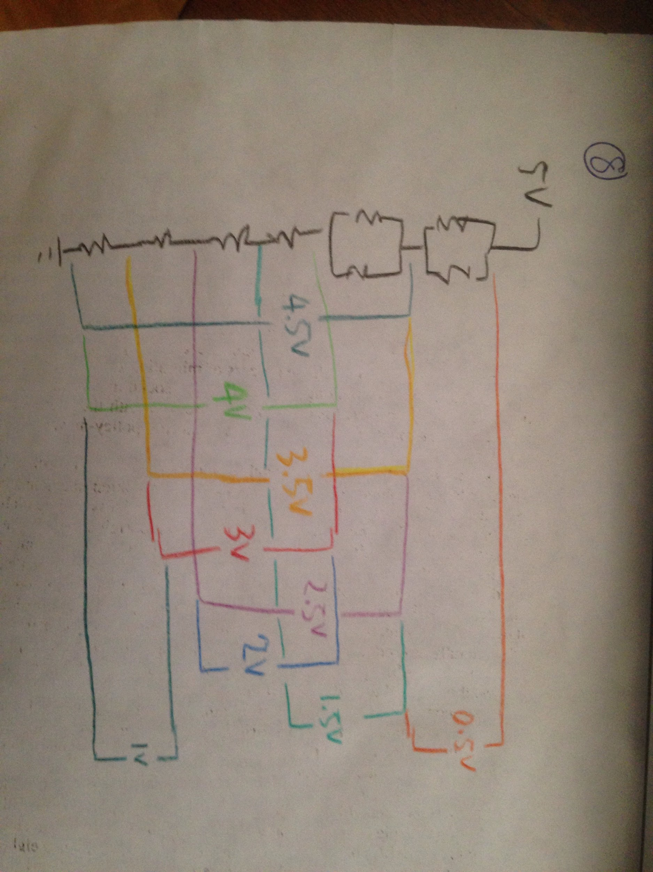

**Figure 1:** Least possible resistors to divide 5V in increments of 0.5V.

**Appendixes**

**Appendix A:** Measured resistances

|  |  |  |  |
| --- | --- | --- | --- |
| Resistor | Indicated resistance(k-ohm) | Measured resistance(k-ohm) | Uncertainty |
| R1 | 2.7 | 2.6374 | 0.00005 |
| R2 | 4.7 | 4.602 | 0.0005 |
| R3 | 8.2 | 7.965 | 0.0005 |
| R4 | 2.7 | 2.6175 | 0.00005 |
| R5 | 4.7 | 4.548 | 0.0005 |
| R6 | 8.2 | 8.016 | 0.0005 |

**Appendix B:** Sample calculations

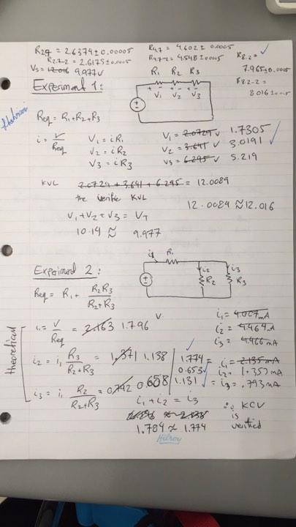

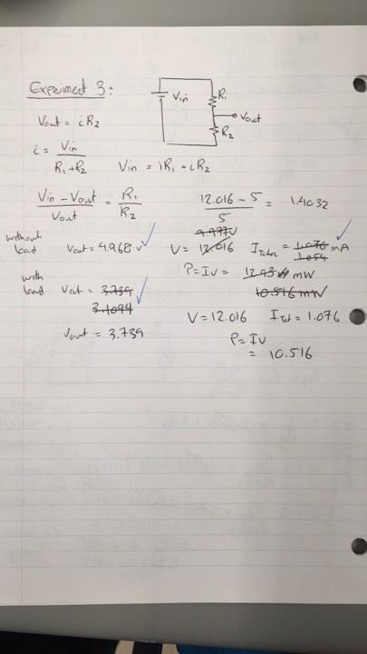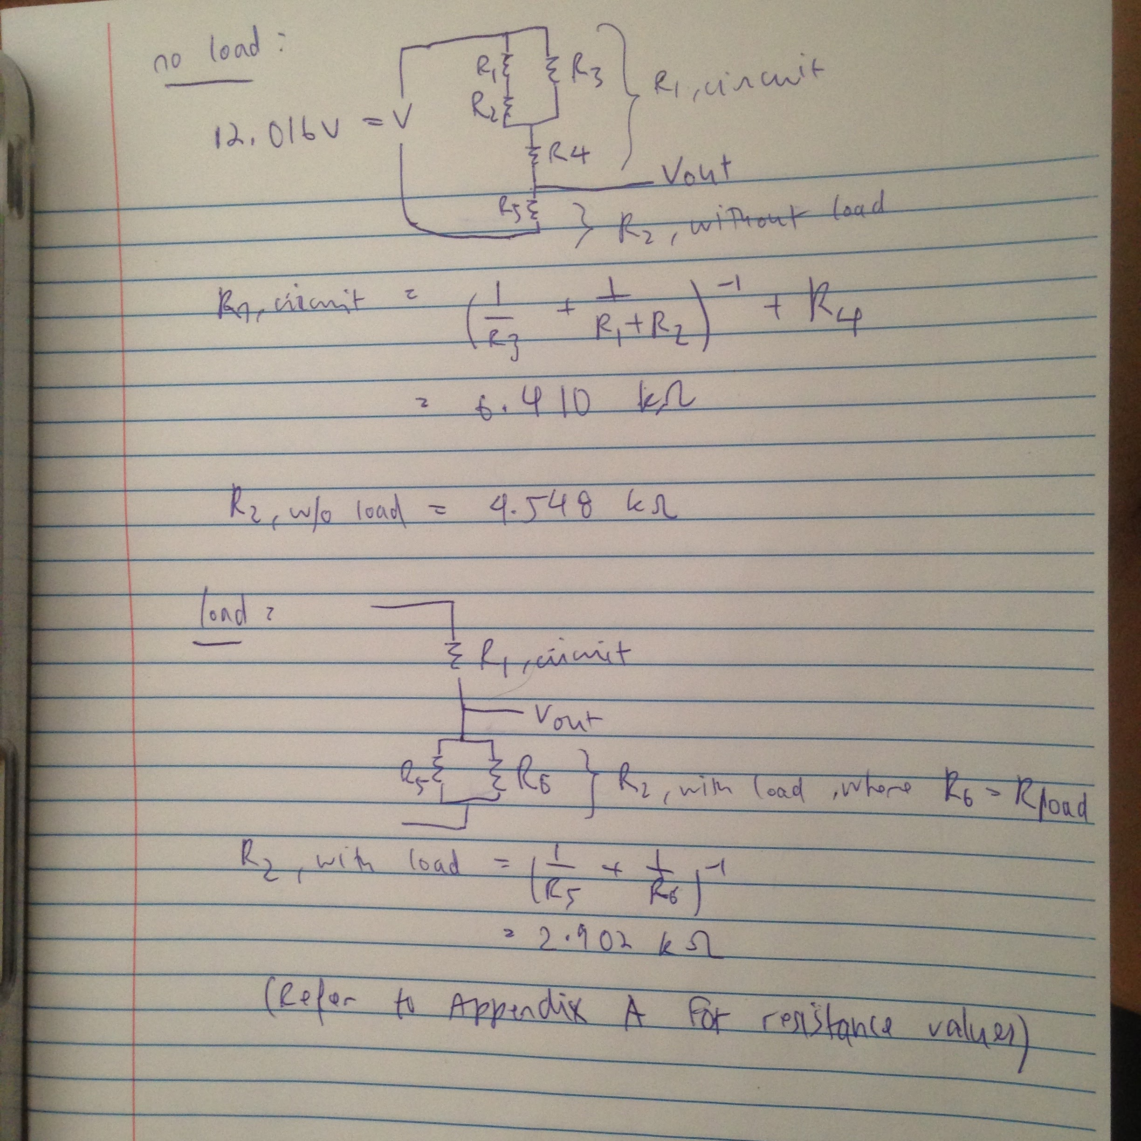

**Appendix C:** Uncertainty calculations

Experiment 1

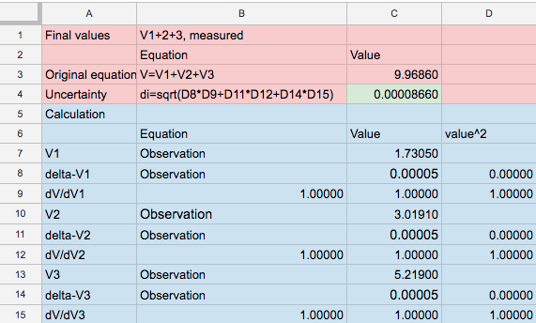

Experiment 2

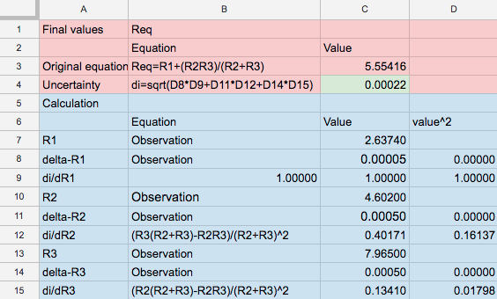

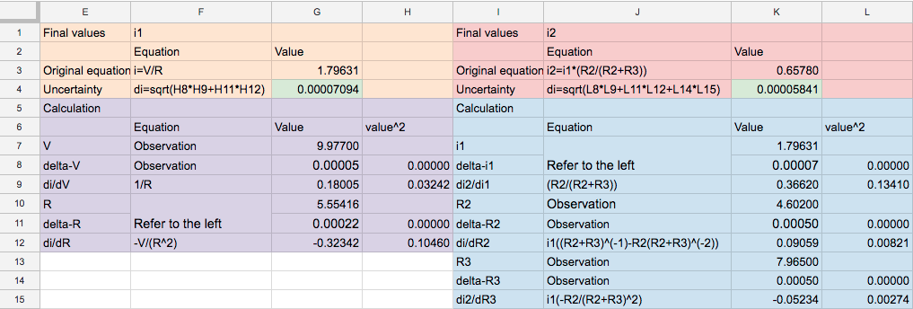

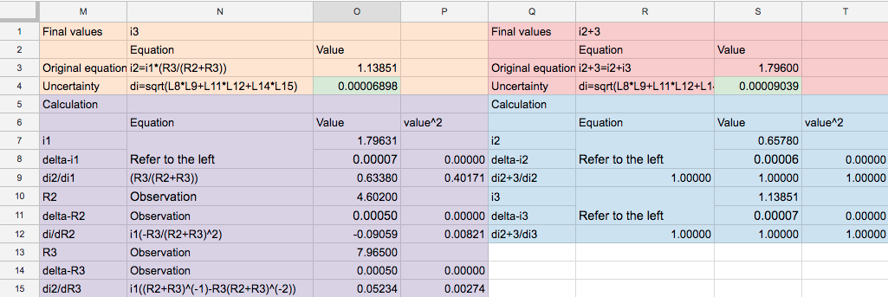

Experiment 3

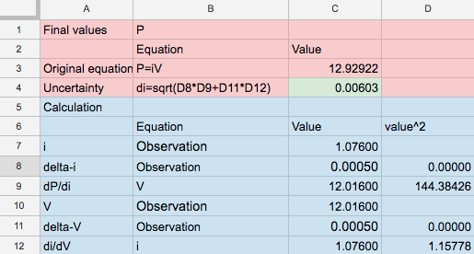

**Note:** For in-depth calculations, please visit the spreadsheet used to do the calculations:

<https://docs.google.com/spreadsheets/d/1q6AhIfTLvrMMQnPpYp2_ZZHFJrWaBpJJVM-lMAavN-4/edit?usp=sharing>